DEPARTMENT OF NATURAL SCIENCES
LESSON PLAN
NAME OF TEACHER: ……………………… DATE:
SUBJECT: MATHMATICS DURATION:80MINUTES
TOPIC: QUADRATIC FUNCTION CLASS: 11
SUBTOPIC: INTRODUCTION TO QUADRATIC FUNTION
NO OF BOYS…….
GIRLS…….
REFERENCES: Progress in mathematics grade 11 pg 78
TEACHING LEARNING /AIDS: learners book, chalk board and chart
RATIONALE: This lesson is on introduction to quadratic function. Teacher Exposition, Demonstration, Question and answer and group or class discussion methods will be used. This lesson will develop learners knowledge Meaning of quadratic function and its graph, Sketching the graph and identifying Maximum and minimum Roots/zeros. The skill of Identification of a quadratic function. Interpretation of Maximum and minimum of function. And Drawing of function graph. The value Neatness in sketching graphs and Logical thinking in determining the turning point
LEARNING OUTCOMES: L.S.B.A.T:
- Explain the quadratic function and its graph
- Sketch the graph of a quadratic function
PREREQUISITE KNOWLEDGE: Learners have ideas about the topic being taught.
LESSON INTRODUCTION revises through the previous lesson
LESSON DEVELOPMENT
CONTENT | TEACHER’S ACTIVITY | PUPIL’S ACTIVITY
SKETCHING A GRAPH OF A QUADRATIC FUNCTION  EXAMPLE  Sketch the graph of Y=2-x-x2 and find the coordinates of the turning point, as will all the intercept with the exes.  SOLUTION  Using the quadratic formula to find x-intercept  A=-1  B=-1  C=-2  X=-2 or x=1  To find the turning point use the two formula given  - X=  - y=  solving for x-cordinates  x=  =  =  Solving for y-cordinates  y=  =  =  =  =2  the graph will be sketched as presented below  -2 1  Y=2-x-x2  EXERCISE  Sketch the graph of the following .show the coordinates of the following points ,as well as the intercepts with the axes  - y=x2+5x-6  - y=2-x-3x2 | Teacher to write the example on the board  Teacher to solve on the board  Teacher draw the graph Y=2-x-x2  Teacher to write the exercise on the board | Learners to write the example in their exercise books  Learners to listen attentively  Learners to pay attentively  Learners to write the exercise in their exercise books  EXPECTED ANSWERS  Q1  a.  X=1 or x=-6  The x intercept has the coordinates (1,-6)  solving for x-cordinates  x=  =  =  Solving for y-cordinates  y=  =  =  =  =12.3  B.  X=0 or x=0.6  The x intercept has the coordinates(0,0.6)  Solving for y-cordinates  y=  =  =  =2  Solving for x-cordinates  x=  =
Lesson conclusion: Tr to conclude lesson by revising through the lesson with leaners to help remedial learners
Learners evaluation:

Teachers evaluation:
GEOGRAPHICAL PRESENTATION OF QUESTION 1.
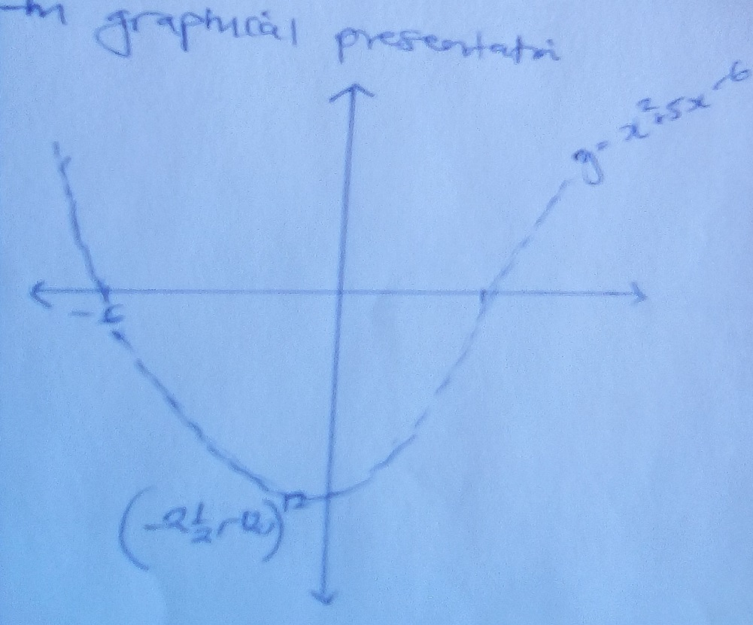

Geographical presentation of question B


